Cau1:

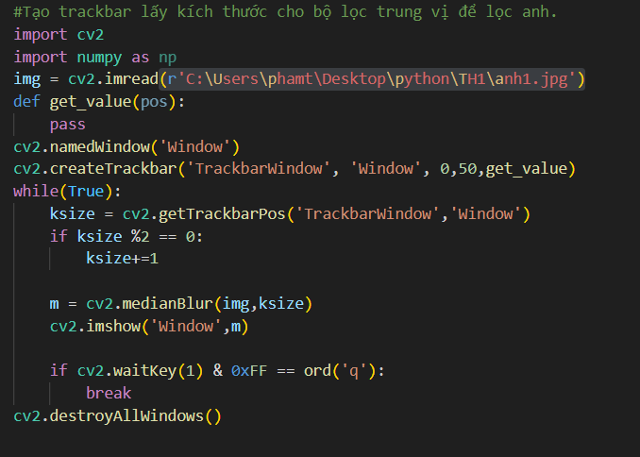

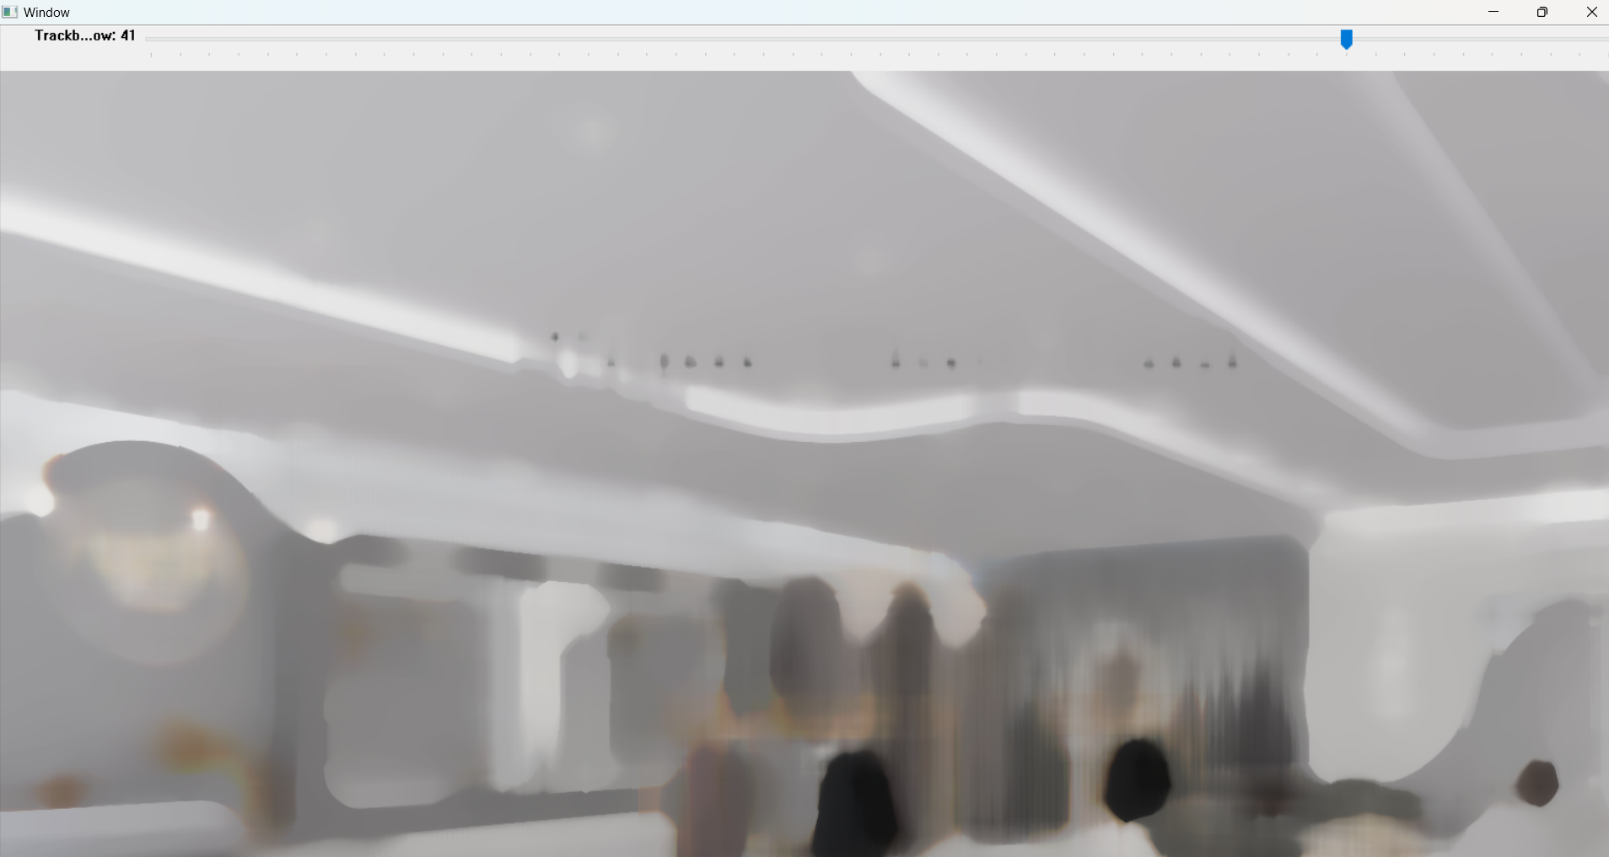

Cau 2:

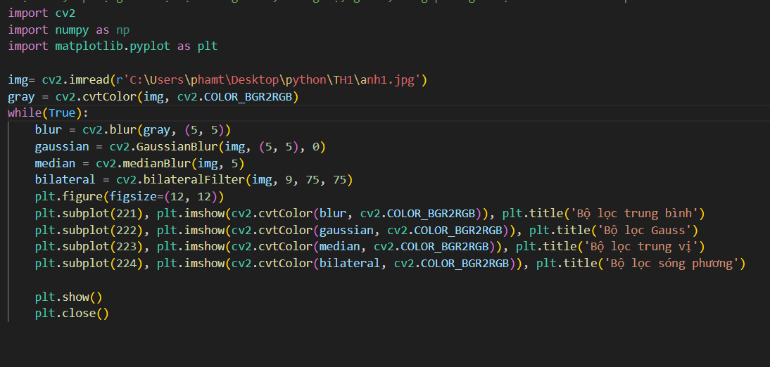

Cau 3:

Cau 4:

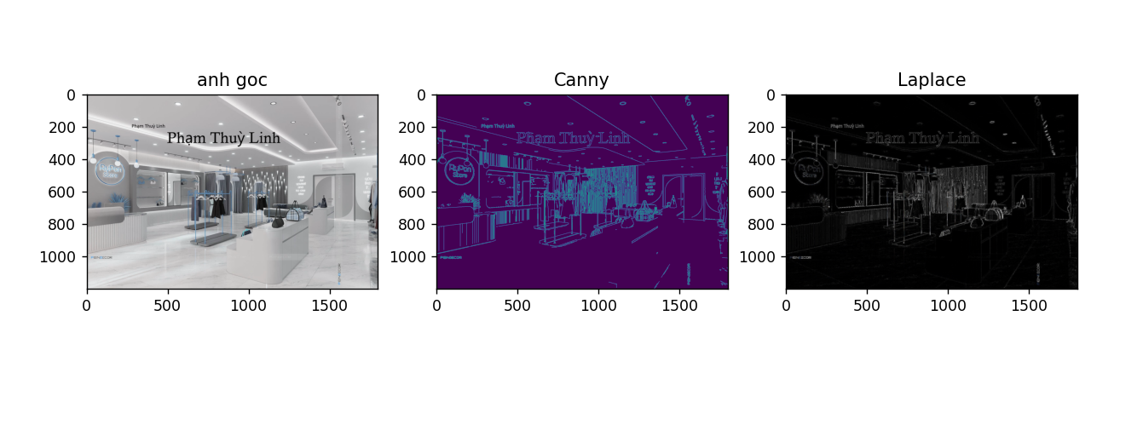

Cau 5:

Cau 6:

